SOME FACTORY ITEMS PICTURE
Product Name | Product Picture | Country of Origin
Top Mount  Bracket | 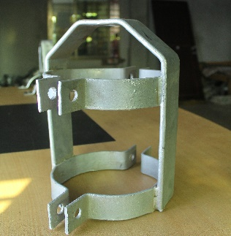 | BANGLADESH
Side Mount  Bracket | 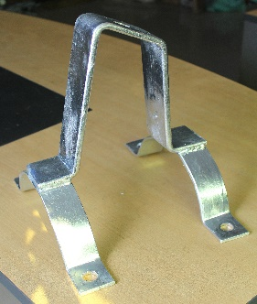 | BANGLADESH
Cross Arm | 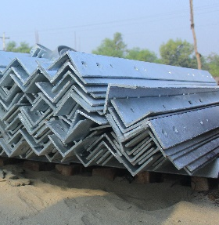 | BANGLADESH
Cross Arm Tie | 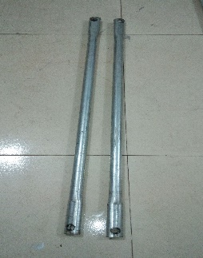 | BANGLADESH
5-Spool Rack | 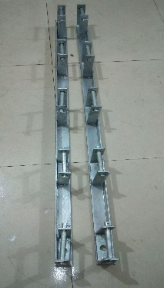 | BANGLADESH
Extension Strap | 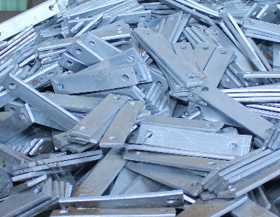 | BANGLADESH
Earthing Rod | 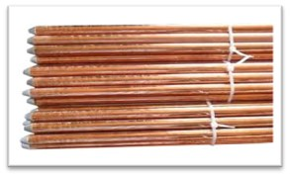 | BANGLADESH
Pole Band | 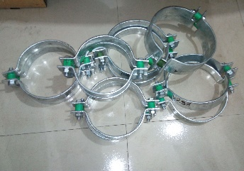 | BANGLADESH
Pole Bracket Strap | 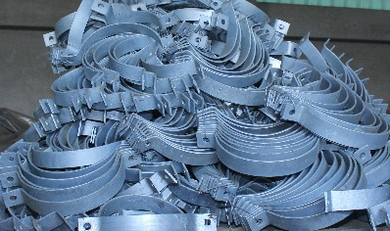 | BANGLADESH
H-Type Connector | 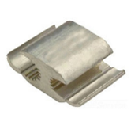 | BANGLADESH
Terminal Lug | 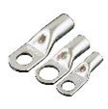 | BANGLADESH
PG Clamp | 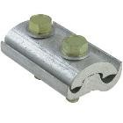 | BANGLADESH
Nut-Bolt | 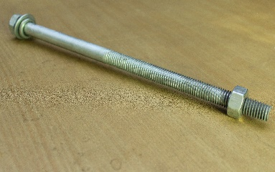 | BANGLADESH

